

SIF Gradebook Working Group
Object Plan

VERSION 3.0
June 5, 2006

www.sifinfo.org
Contributors
The following individuals created version 1.0 of this Document:
John Graff | Editor
Bill Duncan | Contributor
Erik Marin | Contributor
Keith Gruenberg | Contributor
Scott Hamilton | Contributor
Dan Stoval | Contributor
Verrdon Mason | Contributor

Change Control
Version | Date | Description | Editor
1.0 | 10/14/05 | Draft for group approval | John Graff
1.2 | 10/18/05 | Updated Draft with additional objects | Dan Stovall
2.0 | 11/03/05 | All objects included | Dan Stovall
2.1c | 11/29/05 | Infrastructure, Chart & Calendar changes, | Dan Stovall
2.2 | 12/13/05 | Final Edits, pg 8, 12 edits | John Graff
2.3 | 1/16/2006 | Changes to reflect the use of two objects for the StudentPeriodAttendance data | Erik Marin
2.3 | 1/17/2006 | Changed the StudentScore object’s name to GradingAssignmentScore | Erik Marin
2.4 | 2/21/2006 | Comments from face to face mtg | John Graff
2.5 | 03/01/06 | Added audit trail information and comment tag to Period Attendnace Objects | Dan Stovall
2.9 | 05/23/06 | Added FAQ, Test Plan and Results | Dan Stovall
3.0 | 06/05/06 | Repeating element clarification | Bill Duncan

Table Of Contents

Table Of Contents 3
Overview 5
Business & Use Cases 6
1.Report Card / Grades Reporting 6
Use Case 1.1 (MarkValueInfo, MarkInfo, SectionMarkInfo) 6
Use Case 1.2 (MarkValueInfo, MarkInfo, SectionMarkInfo) 6
Use Case 1.3 (StudentSectionMarks) 6
Use Case 1.4 (StudentSectionMarks) 6
Use Case 1.5 (StudentSectionMarks) 6
2.Official (and unofficial) Student Period Attendance 6
Use Case 2.1 (OfficialStudentPeriodAttendance) 7
Use Case 2.2 (Un-Official StudentPeriodAttendance) 7
Use Case 2.3 (StudentPeriodAttendance) 7
Use Case 2.4 (StudentPeriodAttendance) 7
Use Case 2.5 (StudentPeriodAttendance) 8
Use Case 2.6 (StudentPeriodAttendance) 9
Use Case 2.7 (StudentPeriodAttendance) 9
Use Case 2.8 (StudentPeriodAttendance) 9
3.Assignment Information 9
Use Case 3.1 (GradingCategory, GradingAssignment) 9
Use Case 3.2 (GradingCategory, GradingAssignment) 9
Use Case 3.3 (GradingAssignmentScore) 9
Use Case 3.4 (GradingAssignmentScore) 10
Use Case 3.5 (GradingAssignmentScore) 10
Time Line 11
Object Dependencies 12
Object Changes 13
Infrastructure Changes 14
Object Description 16
1.MarkValueInfo 16
2.MarkInfo 19
3.SectionMarkInfo 20
4.StudentSectionMarks 22
5.GradingCategory 24
6.GradingAssignment 25
7.GradingAssignmentScore 27
8.StudentPeriodAttendance 29
9.OfficialStudentPeriodAttendance 30
Test Plan 33
Test Cases 33
Report Card / Grades Reporting 33
Student Period Attendance 33
Grading Assignments 33
Test Results 35
Use Cases used for Testing Object 35
Test Cases used for Testing Object 35
Test Script Procedures Log 37
Result Table 37

Overview
The purpose of this document is to record a detailed description of each of the objects proposed by the Gradebook Working Group to be included in the 2.0 SIF Specification. This document attempts to detail each attribute and purpose of each object, object interactions and dependencies. Use cases will be refined to be used as the basis for test cases during object testing.

Business & Use Cases
The following business cases were created by the group to drive the creation of the 2.0 Gradebook object specification. Preference in the development cycle is planned for business cases that are actively championed by members of the group who can help with both development and testing of the objects.

Report Card / Grades Reporting
Districts select best-of-breed gradebooks for teacher-classroom usage. The School administrator creates the grading configuration in the SIS. The gradebooks update their grading configuration from the SIS.

Use Case 1.1 (MarkValueInfo, MarkInfo, SectionMarkInfo)
The school administrator sets up the grading configuration and the SIS publishes the configuration for subscribers (e.g. gradebook applications).

Use Case 1.2 (MarkValueInfo, MarkInfo, SectionMarkInfo)
The gradebook requests the grading configuration for a school and the teacher’s classes and the SIS responds with the appropriate setup information.

Teachers enter final grades into the gradebook. Grades are then harvested back into the school buildings’ student information system for long term storage, transcripts, and data warehousing / analysis.

Use Case 1.3 (StudentSectionMarks)
The gradebook teacher indicates that grades entry is complete and the grades are published for subscribers (e.g. SIS application).

Use Case 1.4 (StudentSectionMarks)
The gradebook teacher updates some previously published grades and the changes are published for subscribers (e.g. SIS application).

Use Case 1.5 (StudentSectionMarks)
The SIS or Portal application requests the current section marks for a student or section at any point in the term and the Gradebook responds with the appropriate information.

Official (and unofficial) Student Period Attendance
A Medical Records Management System (MRMS) that contains a services scheduling component wants to receive data from a Student Information System (SIS). The MRMS is tracking individual student medication and health services schedules based on reoccurring timeframes. With this data, the MRMS can reconcile missed scheduled services in the health record. The MRMS is also the primary software interface for school health and special education staff. The MRMS could provide a means to record period attendance when necessary.

Use Case 2.1 (OfficialStudentPeriodAttendance)
The MRMS will receive official student period attendance information from the SIS system (via the OfficialStudentPeriodAttendance object) in order to properly document missed health services or appointments. This reconciliation process is required by the health industry standards and best practices. In addition it will properly document private insurance and/or Medicaid events. This documentation can then be used to validate insurance billing and reduce Medicaid audit risk.

Use Case 2.2 (Un-Official StudentPeriodAttendance)
The MRMS could send student period attendance information to the SIS system (via the StudentPeriodAttendance object). The sending of this information is initiated from the MRMS by the school nurse, special education professional, or staff member when a student is in the health room for an extended period of time.

District / school administrator separates collection of classroom period attendance(gradebook) from the product which is used to calculate daily attendance and ADA / ADM (SIS). This allows the two distinct user groups of teachers and administrative staff to select software products that best suit their individual needs. The software used by the adminstrative staff is designated the “Official System” for student period attendance and will be used for state reporting and auditing.

Only the “official” period attendance system will generate events and respond to requests for OfficialStudentPeriodAttendance. Any other agent in the zone that collects attendance could publish StudentPeriodAttendance events which would get processed by the “official” attendance system. If the attendance data contained in the (un-official) StudentPeriodAttendance objects is accepted by the “official” attendance system, it’s agent will generate OfficialStudentPeriodAttendance events that will notify all other parties that the change was made. If the un-official attendance is not accepted by the “official” attendance system, it will publish an event that notifies all subscribers what the correct attendance is. The expectation is that the publisher of the rejected attendance will change the data recorded in their system to match that of the official system in order to stay in sync.

Use Case 2.3 (StudentPeriodAttendance)
The teacher enters section / period attendance for a section and the application agent publishes a StudentPeriodAttendance add event. The “official” attendance system would accept or reject this attendance based on internal logic and then generate an OfficialStudentPeriodAttendance event.

Use Case 2.4 (StudentPeriodAttendance)
The teacher updates section / period attendance in for a section and the application agent publishes a StudentPeriodAttendance change event. The “official” attendance system would accept or reject this attendance based on internal logic and then conditionally generate an OfficialStudentPeriodAttendance event.

Use Case 2.5 (StudentPeriodAttendance)
The SIS application requests section / period attendance for a teacher or section and the gradebook application agent responds with the appropriate data.

A web portal customized for a teacher integrates data from a variety of sources with the school district. The gradebook data is critical to allow the teacher to make data driven decisions in the classroom. Teachers, parents, and students may track student attendance and communicate with each other through the portal. For instance, a teacher may log into the portal and compare student performance with their attendance, gather resources to help students, and send messages to the student or their parents with information on those resources.

Use Case 2.6 (StudentPeriodAttendance)
The web portal periodically requests all OfficialStudentPeriodAttendance for a school and updates the content available to all its users.

Use Case 2.7 (StudentPeriodAttendance)
A teacher logs in to the web portal and wishes to review the attendance information. The portal requests the OfficialStudentPeriodAttendance information for all of the teachers classes, or the particular class they are viewing, and updates it’s content in real time

Use Case 2.8 (StudentPeriodAttendance)
A student or parent logs in to the web portal and wishes to review their attendance information. The portal requests the OfficialStudentPeriodAttendance information for all of the student’s classes, or the particular class they are viewing, and updates it’s content in real time

Assignment Information
Grading categories are created by each teacher as a way to group the assignments that exist in their gradebook. Assignments are created by each teacher in their gradebook and assigned to a grading category. Student scores are entered into the gradebook for each student for each assignment. Assignment information tracked in gradebook (grading categories, assignment information, and student scores) is made accessible to SIS and Portal applications. Assignment information may be queried for long term storage, data warehousing / analysis, or publication of assignment information to parents.

Use Case 3.1 (GradingCategory, GradingAssignment)
Grading categories are entered in the gradebook, either manually or by querying them from the SIS. The teacher enters assignments into the gradebook for each of their classes. Assignment information is them published to the SIS or portal either through events or by requests.

Use Case 3.2 (GradingCategory, GradingAssignment)
The teacher updates previously published grading category or assignment information in their gradebook. The SIS or portal receives the changes when the SIF change events are sent.

Use Case 3.3 (GradingAssignmentScore)
The teacher enters assignment scores for an assignment for each student. The score for each student is published to the SIS or portal, either through events or through requests.

Use Case 3.4 (GradingAssignmentScore)
The gradebook teacher updates some previously published assignments and the changes are published for subscribers (e.g. SIS or Portal application).

Use Case 3.5 (GradingAssignmentScore)
The SIS or Portal application requests all school assignments based on any number of filter parameters, including zero parameters. Parameters may include, but are not limited to Teacher, Student, Class, Section, Grading Period, etc. The gradebook responds with the organization’s assignment information narrowed by any parameters provided.

Time Line
The following time line has been approved by the working group.

 | Start Time | End Time
Business Case Development | 21-Sep-05 | 29-Sep-05
Object Proposal 1st Draft | 27-Sep-05 | 3-Oct-05
WG Member Review of Object Proposal | 4-Oct-05 | 6-Oct-05
Object Proposal Submitted to ED and EAB | 6-Oct-05
Finalize Objects needed for use cases | 4-Oct-05
Review Object Group 1 (mark value info, mark info, section mark info) | 11-Oct-05
Review Object Group 2 (student section marks, student period attendance) | 18-Oct-05
Review Object Group 3 (grading category, assignment info, student score) | 25-Oct-05
Final WG member review Spec 2.0 | 6-Dec-05
Objects posted for SIFA member review | 13-Dec-05 | 12-Jan-06
Handle Infrastructure changes, Infrastructure call | 21-Dec-05
Review Feedback, and Testing Plans, finalize beta and alpha testing | 10-Jan-06
Last Mtg to plan Connect-a-thon | 28-Feb-06
Connect-a-thon (alpha testing) | 7-Mar-06
Begin Beta testing (Optional) | 14-Mar-06
Final Draft Review before Tech Board submission | 11-Apr-06
Grade Book Spec submitted to Tech Board | 15-Apr-06
Tech board mtg to approve | 22-Apr-06
Highlight corresponds to Group’s call

Object Dependencies
The current version of specification has links to existing objects in SIF. It is also planned that many of the proposed objects will link to each other. The following chart reflects the current object model. Items shaded in grey are new Gradebook objects. White objects are existing SIS objects.
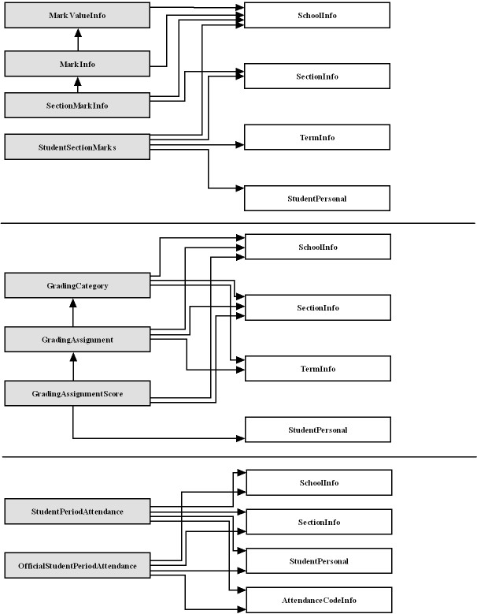

Object Changes
There are two objects in the current specification that will need to be changed in order to support the proposed gradebook objects. Both of the objects are currently undergoing changes for the 2.0 specification and are expected to include the fields we require when they are approved.
The first object we require changes to is TermInfo. We require that there be a way to indicate whether a term is defined for one or more of the following purposes: scheduling, grading and attendance.
The second object we require changes to is AttendanceCodeInfo. We require that there be a way to indicate whether an attendance code is used for one or more then the following: period attendance or daily attendance.

Infrastructure Changes

There are currently no infrastructure changes required in order to use the proposed Gradebook objects. However, some of the StudentPeriodAttendance use cases proposed by the Gradebook working group were difficult to implement using the SIF model and infrastructure.

The specific issue is with multiple event publishers for the StudentPeriodAttendance object. There is currently a lot of ambiguity surrounding the following scenario: two systems generate StudentPeriodAttendance events for the same student/section/period/date, at roughly the same time. The resulting attendance code that gets recorded in any given system would be determined by which event got queued up first.

There is also no way to manage user precedence in the zone. Example: A teacher using a gradebook should not be able to change attendance that has been entered by the attendance clerk who uses the SIS to edit attendance.

Both of these scenarios are un-acceptable for the management of StudentPeriodAttendance data because of the financial and legal issues associated with publishing inaccurate attendance data to state agencies or parents.

It all seemed to boil down to the fact that the event model used by SIF was not initially intended to be used to keep multiple applications in a zone in sync… It was intended to allow applications in a zone to notify others when changes occur in their system. There is currently no way using the SIF infrastructure or object model to ensure that all products participating in a zone contain exactly the same data for any given object. Because of this, we were forced to develop our own process to try to ensure that the integrity of the attendance data in a zone could be preserved.

Our solution involves using two objects to manage period based attendance for students. There is an “official” object (OfficialStudentPeriodAttendance - OSPA) and on “un-official” object (StudentPeriodAttendance - SPA). We intend for there to only be one publisher of events for OSPA in a zone. Any events containing OSPA data must be accepted by all subscribers and be used to update their systems so that the attendance in every system is equivalent to the attendance contained in the “official” system. Any agent in a zone can publish SPA events. The only system in the zone that subscribes to the un-official attendance events should be the “official” attendance system. The “official” attendance system is responsible for determining whether the “un-official” attendance events should be accepted and recorded based on the source of the attendance data, the user who created the attendance event and the user who was responsible for the creation of the current “official” attendance. The SIF_Header SourceId and the AuditInfo node of the SPA object are intended to facilitate the logic necessary for making decisions about which attendance to accept or reject. Regardless of whether the “official” system accepts or rejects attendance from any other agent in the zone, it is responsible for publishing an OSPA event for every “un-official” SPA event that it receives. The “official” event will contain the affected attendance, which will either reflect the changes contained in the “un-official” event, or will reflect the un-changed “official” attendance, if the event was rejected. All systems in the zone are expected to heed the OSPA events and update their system so that their current attendance data reflects the attendance in the “official” system.

This messaging model cannot be enforced in a zone. There is no way to ensure that the attendance contained in the “official” system correctly represents the combination of all of the events generated by the contributing systems. If a District/School chooses to allow multiple publishers of attendance data to exist in a zone, they will have to carefully select vendors that have implemented the logic necessary to ensure that the integrity of the attendance data is preserved. It might also be advisable to keep a permenant record of the attendance related event messages that passed through the ZIS, so that conflicts over the correctness of the “official” attendance could be researched and resolved.

Object Description

MarkValueInfo
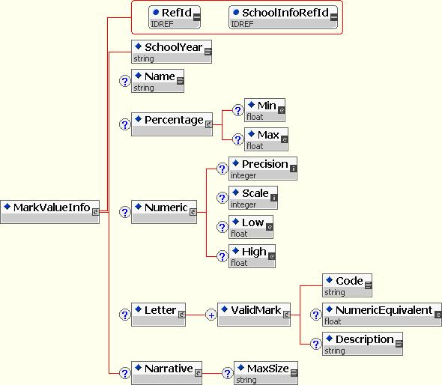
Name | MarkValueInfo
Description | This object defines the types of values allowed for a mark and the domain for each mark value. At least one of the Percentage, Numeric, Letter or Narrative nodes must be used to create a valid MarkValueInfo.
Type | Object
Status | Draft Submission
Use Cases | 1.1, 1.2
Supports Events | Yes
Revision History | 03/08/05 – submitted, 03/22/05 – revised, 09/26/05 – revised, 11/01/05 – revised, 06/05/06 – revised
Rev. Date | 06/05/06
Element | Attrib | Char | Description
MarkValueInfo |  | M | Defines a list of valid values for one or more MarkInfo objects
 | RefId | R | The ID (GUID) that uniquely identifies this MarkValueInfo entity
 | SchoolInfoRefId | R | The ID (GUID) that uniquely identifies the School that these Mark Values apply to
SchoolYear |  | M | The year that this MarkValueInfo applies to
Name |  | M | The text name of the value list (“Letter Grades”, “Letter Grades (+/-)”, “ESU”, “Pass/Fail”, “Override Grades”, “Citizenship Comment Codes”, etc.)
Percentage |  | C | Indicates whether a percent Mark is accepted (format ##0.00)
Percentage/Min |  | O | The minimum percent value accepted for this mark. If present, the publisher of this object is required to ensure that any values present in the StudentSectionMarks object will not be lower than this value.
Percentage/Max |  | O | The maximum percent value accepted for this mark. . If present, the publisher of this object is required to ensure that any values present in the StudentSectionMarks object will not be higher than this value.
Numeric |  | C | Indicates whether a raw numeric score is accepted
Numeric/  Precision |  | O | Number of significant digits
Numeric/  Scale |  | O | Number of decimal places
Numeric/  Low |  | O | Lowest Mark in the range (e.g., 98, 3.95)
Numeric/  High |  | O | Highest Mark in the range (e.g., 100, 4.0)
Letter |  | C | Indicates whether a letter Mark is accepted
Letter/  ValidMark |  | MR | List of specific valid letter Marks (Primary Key = Code)
Letter/  ValidMark/  Code |  | M | String representing the actual Mark that would appear on the report card (e.g., “A+”, “I”, “100”).
Letter/  ValidMark/  NumericEquivalent |  | O | Numeric equivalent for the Mark (e.g., 100, 4.0).
Letter/  ValidMark/  Description |  | O | The description for this code. (e.g. “Excellent”, “Participates in Class”, “Incomplete”, etc…)
Narrative |  | C | Indicates whether a free-form text narrative is accepted
Narrative/  MaxSize |  | O | An integer value representing the maximum number of characters for the narrative

<?xml version = "1.0"?>
<MarkValueInfo RefId = "11737E214A7C46BDBA4301CADCA75C87" SchoolInfoRefId = "11737E A4301CADCA75C87214A7C46BDB">
<SchoolYear>2004</SchoolYear>
<Name>Letter Grades</Name>
<Letter>
<ValidMark>
<Code>A</Code>
<NumericEquivalent>100</NumericEquivalent>
</ValidMark>
<ValidMark>
<Code>B</Code>
<NumericEquivalent>90</NumericEquivalent>
</ValidMark>
<ValidMark>
<Code>C</Code>
<NumericEquivalent>80</NumericEquivalent>
</ValidMark>
<ValidMark>
<Code>D</Code>
<NumericEquivalent>70</NumericEquivalent>
</ValidMark>
<ValidMark>
<Code>F</Code>
<NumericEquivalent>60</NumericEquivalent>
</ValidMark>
</Letter>
</MarkValueInfo>

<?xml version = "1.0"?>
<MarkValueInfo RefId = "11737E214A7C46BDBA4301CADCA75C87" SchoolInfoRefId = "11737E A4301CADCA75C87214A7C46BDB">
<SchoolYear>2004</SchoolYear>
<Name>Numeric Grade</Name>
<Numeric>
<Precision>6</Precision>
<Scale>2</Scale>
<Low>0</Low>
<High>1000</High>
</Numeric>
</MarkValueInfo>

<?xml version = "1.0"?>
<MarkValueInfo RefId = "11737E214A7C46BDBA4301CADCA75C87" ShoolInfoRefId = "11737EA4301CADCA75C87214A7C46BDB">
<SchoolYear>2004</SchoolYear>
<Name>Free Form Comment</Name>
<Narrative>
<MaxSize>255</MaxSize>
</Narrative>
</MarkValueInfo>

MarkInfo
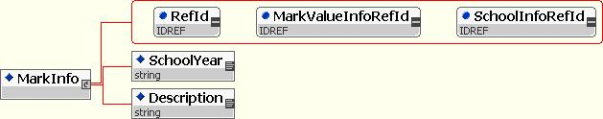

Name | MarkInfo
Description | This object defines a mark that is getting recorded and associates it with a MarkValueInfo object that lists the types of values and valid values for each type.
Type | Object
Status | Draft Submission
Use Cases | 1.1, 1.2
Supports Events | Yes
Revision History | 03/08/05 – submitted, 03/22/05 – revised, 09/26/05 – revised
Rev. Date | 09/26/05
Element | Attrib | Char | Description
MarkInfo |  | M | Defines each mark that can be reported. Places the definition in the context of a school and school year.
 | RefId | R | The ID (GUID) that uniquely identifies this Grading Mark entity
 | MarkValueInfoRefId | R | The ID (GUID) that uniquely identifies the MarkValueInfo
 | SchoolInfoRefId | R | The ID (GUID) that uniquely identifies the School that this Mark applies to
SchoolYear |  | M | The year that this MarkInfo applies to
Description |  | M | Textual description of the type of Mark (e.g. “Marking Period Grade”, “Comment 1”, “Comment 2”, ”Conduct”, “Effort”, “WorkHabits”).

<?xml version = "1.0"?>
<MarkInfo RefId = "46BDBA4301C11737E214A7CADCA75C87" MarkValueInfoRefId = "301CADCA7511737E214A7C46BDBA4E23" SchoolInfoRefId = "11737EA4301CADCA75C87214A7C46BDB">
<SchoolYear>2004</SchoolYear
<Description>Marking Period Grade</Description>
</MarkInfo>

<?xml version = "1.0"?>
<MarkInfo RefId = "11737E214A7C46BDBA4301CADCA75C87" MarkValueInfoRefId = "11737E214A7C46BDBA4301CADCA75E23" SchoolInfoRefId = "11737EA4301CADCA75C87214A7C46BDB">
<SchoolYear>2004</SchoolYear>
<Description>Conduct Grade</Description>
</MarkInfo>

SectionMarkInfo
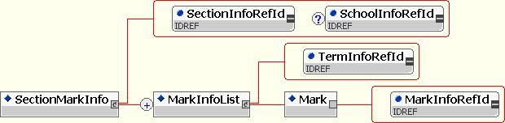

Name | SectionMarkInfo
Description | This object relates a SectionInfo object to the marking periods (TermInfo) that mark are recorded in and then lists the types of marks (MarkInfo) that are recorded in each marking period.
Type | Object
Status | Draft Submission
Use Cases | 1.1, 1.2
Supports Events | Yes
Revision History | 03/08/05 – submitted, 03/22/05 – revised, 09/26/05 – revised, 06/05/06 – revised
Rev. Date | 06/05/06
Element | Attrib | Char | Description
SectionMarkInfo |  | M | Defines the marking periods (TermInfo) that marks (StudentSectionMarks) are recorded in for a particular section (SectionInfo) and lists the marks (MarkTypeInfo) that are valid for that marking period (TermInfo).
 | SectionInfoRefId | R | The ID (GUID) that uniquely identifies the SectionInfo object that this item refers to
 | SchoolInfoRefId | R | The ID (GUID) that uniquely identifies the School that these Mark Values apply to
MarkInfoList |  | MR | The grading-related information for a section, repeating for each marking period (TermInfo) in which the section reports Marks. (Open List)
 | TermInfoRefId | R | The ID (GUID) that identifies the marking period that the following marks are recorded in.
MarkInfoList\Mark |  | M
 | MarkInfoRefId | R | The ID (GUID) that identifies a mark that this class uses for grading

<?xml version = "1.0"?>
<SectionMarkInfo SectionInfoRefId = "11737E214A7C46BDBA4301CADCA75C87" SchoolInfoRefId = "11737EA4301CADCA75C87214A7C46BDB">
<MarkInfoList TermInfoRefId = "BDBA4301CA1A7C461737DCA75C87E214">
<Mark MarkInfoRefId = "A7C46BDBA4301CA11737E214DCA75C87"/>
<Mark MarkInfoRefId = "BA4301CADCA75C8711737E214A7C46BD"/>
</MarkInfoList>
<MarkInfoList TermInfoRefId = "01CA1BDBA43A7C461737DCA75C87E214">
<Mark MarkInfoRefId = "A7C46BDBA4301CA11737E214DCA75C87"/>
<Mark MarkInfoRefId = "BA4301CADCA75C8711737E214A7C46BD"/>
</MarkInfoList>
</SectionMarkInfo>

StudentSectionMarks
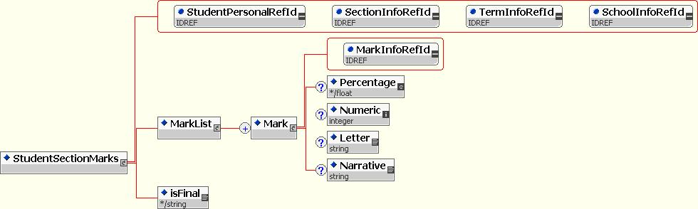

Name | StudentSectionMarks
Description | Associates a StudentSectionEnrollment object with the grades that they received for the Section in the context of a particular Term. One or more of the Percentage, Numeric, Letter or Narrative fields should always be filled in.
Type | Object
Status | Draft Submission
Use Cases | 1.3, 1.4, 1.5
Supports Events | Yes, only when isFinal is Y
Revision History | 03/08/05 – submitted, 03/22/05 – revised, 09/26/05 – revised, 06/05/06 – revised
Rev. Date | 06/05/06
Element | Attrib | Char | Description
StudentSectionMarks |  | M | Associates a StudentPersonal object with a SectionMarkInfo object and lists one or more marks (grades) that were given for one or more terms.
 | StudentPersonalRefId | R | The ID (GUID) that uniquely identifies the StudentPersonal object that this item refers to
 | SectionInfoRefId | R | The ID (GUID) that uniquely identifies the SectionInfo object that this item refers to
 | TermInfoRefId | R | The ID (GUID) that identifies the marking period that the following marks are recorded in.
 | SchoolInfoRefId | R | The ID (GUID) that uniquely identifies the School that these Mark Values apply to
IsFinal |  | R | Indicates if the grades are “Final” from the perspective of the teacher or school. Does not mean that change events will not occur for this item. Valid values are “Y” or “N”.
MarkList |  | M | A list of marks received for this student in this section (Open List). For each Mark entry, at least one of the sub-elements must be specified.
Mark |  | MR | Outer wrapper for marks reported for this section, in this term
 | MarkInfoRefId | R | The ID (GUID) that identifies a mark that was given for this student
Mark/Percentage |  | C | The percent score for this mark (0.00 – 100.00)
Mark/Numeric |  | C | The raw numeric score for this mark
Mark/Letter |  | C | The letter grade for this mark
Mark/Narrative |  | C | The free form text narrative for this mark

<?xml version = "1.0"?>
<StudentSectionMarks StudentPersonalRefId = "11737EA4301CADCA75C87214A7C46BDB" SectionInfoRefId = "11737E214A7C46BDBA4301CADCA75C99" TermInfoRefId = "BDBA4301CA1A7C461737DCA75C87E214" SchoolInfoRefId = "11737EA4301CADCA75C87214A7C46BDB">
<MarkList>
<Mark MarkInfoRefId = "A7C46BDBA4301CA11737E214DCA75C87">
<Percentage>88</Percentage>
<Letter>B</Letter>
</Mark>
<Mark MarkInfoRefId = "737E214A7C46BDBA4301CA11DCA75C87">
<Narrative>Plays well with others and is willing to share with the one exception being food. Student is very possessive of his lunch and becomes very aggressive if anyone attempts to take any of it from him</Narrative>
</Mark>
<Mark MarkInfoRefId = "11737E214A7C46BDBA4301CADCA75E23">
<Letter>A9</Letter>
</Mark>
</MarkList>
<isFinal>Y</isFinal>
</StudentSectionMarks>

GradingCategory
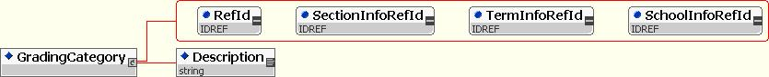

Name | GradingCategory
Description | This object is to provide information about a particular grading category to provide grouping and type information for assignments.
Type | Object
Status | Draft Submission
Use Cases | 4.1, 4.2
Supports Events | Yes
Revision History | 12/31/01 – submitted
Rev. Date | 3/1/04
Element | Attrib | Char | Description
GradingCategory | RefId | R | GUID that identifies a grading category.
 | SectionInfoRefId | R | The GUID for the SectionInfo object that this category is used for grading in.
 | TermInfoRefId | R | The GUID for the TermInfo object that defines the marking period that the category was created in.
 | SchoolInfoRefId | R | The ID (GUID) that uniquely identifies the School that these Mark Values apply to
Description |  | M | The name/short description of the category.

<?xml version = "1.0"?>
<GradingCategory RefId = "98157AA013BA8C3D00AA012B359D7512" SectionInfoRefId = "13BA8C3D00AA098157AA012B359D7512" TermInfoRefId = "D00AA012B359D798157AA013BA8C3512" SchoolInfoRefId = "11737EA4301CADCA75C87214A7C46BDB">
<Description>Tests</Description>
</GradingCategory>

GradingAssignment
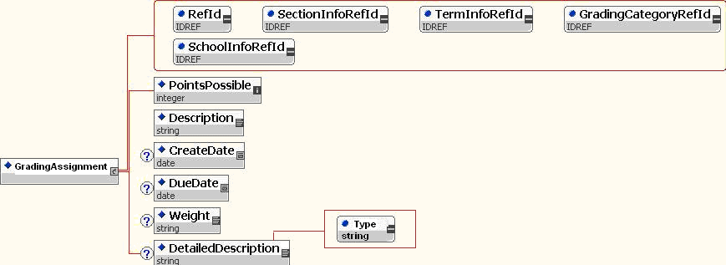

Name | GradingAssignment
Description | This object provides information about a particular assignment, allows applications to synchronize each other’s assignment tables, gathers the definition for a GradingAssignmentScore object, etc.
Type | Object
Status | Draft Submission
Use Cases | 4.1, 4.2
Supports Events | Yes
Revision History | 12/31/01 submitted, 11/01/05 - revised
Rev. Date | 11/01/05
Element | Attrib | Char | Description
GradingAssignment | RefId | R | A GUID that identifies GradingAssignment.
 | SectionInfoRefId | R | The GUID for the SectionInfo object
 | TermInfoRefIId | R | The GUID for the TermInfo object that defines the marking period that the assignment was created in.
 | SchoolInfoRefId | R | The ID (GUID) that uniquely identifies the School that these Mark Values apply to
 | GradingCategoryRefId | R | The GUID for the GradingCategory that this assignment is part of.
Description |  | M | The text-based description of the assignment.
PointsPossible |  | M | The points possible on the assignment.
CreateDate |  | O | Creation date of the assignment.
DueDate |  | O | Date the assignment is due.
Weight |  | O | The weight of the assignment.
DetailedDescription |  | O | This element defines the assignment. If the type attribute is URL, this is the location of the document that describes the assignment. If the type is PDF, this element will contain the Base64 encoded bytes necessary to represent the entire document.
 | Type | R | The type of information that is contained in the DetailedDescription element. Could be a URL or a MIME type.

<?xml version = "1.0"?>
<GradingAssignmentAssignment RefId = "359D75101AD0A9D7A8C3DAD0A8510VA2" SectionInfoRefId = "D0A0A27AD0A8510AD9D75101A8C3DA39" TermInfoRefId = "A8C3A2E35B359D75101D00AA001A0000" GradingCategoryRefId = "98A57A0013BA8C3D00AA012B359D751A" SchoolInfoRefId = "11737EA4301CADCA75C87214A7C46BDB">
<PointsPossible>100</PointsPossible>
<Description>Pop Quiz</Description>
<CreateDate>2000-11-21</CreateDate>
<DueDate>2000-11-25</DueDate>
<Weight>1.0</Weight>
<DetailedDescription Type = "URL">http://www.assignmentinfo.com/assignment1.pdf</DetailedDescription>
</AssignmentInfo>

GradingAssignmentScore
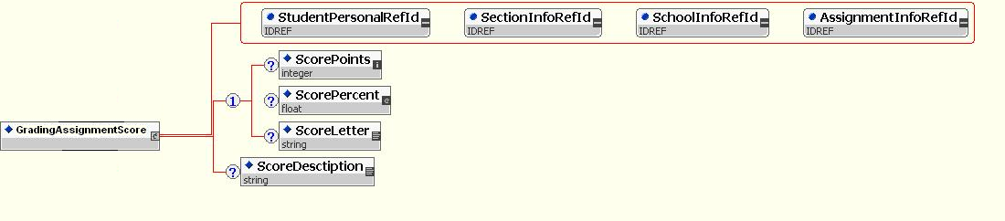
Name | GradingAssignmentScore
Description | This object provides score information about a particular assignment.
Type | Object
Status | Draft Submission
Use Cases | 4.3, 4.4, 4.5
Supports Events | Yes
Revision History | 12/31/01 submitted, 11/01/05 - revised
Rev. Date | 11/01/05
Element | Attrib | Char | Description
GradingAssignmentScore
 | StudentPersonalRefId | R
 | SectionInfoRefId | R
 | SchoolInfoRefId | R | The GUID that specifies the school this score was recorded at
 | GradingAssignmentRefId | R
ScorePoints |  | C | The score represented as points. Conditionally required that one or more of ScorePoints, ScorePercent or ScoreLetter must be filled in.
ScorePercent |  | C | The score represented as a percent. Conditionally required that one or more of ScorePoints, ScorePercent or ScoreLetter must be filled in.
ScoreLetter |  | C | The score represented as a letter grade. Conditionally required that one or more of ScorePoints, ScorePercent or ScoreLetter must be filled in.
ScoreDescription |  | O | Text description of the score.

<?xml version = "1.0"?>
<GradingAssignmentScore StudentPersonalRefId = "A75A00101A8C301D02E3A05B359D0A00" SectionInfoRefId = "D0A0A27AD0A8510AD9D75101A8C3DA39" SchoolInfoRefId = "11737EA4301CADCA75C87214A7C46BDB" GradingAssignmentRefId = "359D75101AD0A9D7A8C3DAD0A8510VD2">
<ScorePoints>45</ScorePoints>
<ScorePercent>90</ScorePercent>
<ScoreDesctiption>Excellent</ScoreDesctiption>
</GradingAssignmentScore>

StudentPeriodAttendance
Name |  | StudentPeriodAttendance
Description |  | This object provides attendance for a student in the context of a SectionInfo object. This object is used by all agents in a zone that provide period attendance, but don’t have the logic to determine whether or not they have sufficient rights to override attendance from another usre or system. Agents that represent a system that can validate attendance based on, among other things, it’s source, should subscribe to StudentPeriodAttendance events to collect “suggested” attendance changes from the zone, and should then publish “accepted” attendance chagnes as OfficialStudentPeriodAttendance events. A rejected change would result in an event that reverts the system that generated the rejected event back to it’s previous state or to some other state that represents the correct “official” attendance.
Type |  | Object
Status |  | Draft Submission
Use Cases |  | 3.1, 3.2, 3.3, 3.4, 3.5, 3.6, 3.7, 3.8
Supports Events |  | Yes
Revision History |  | 12/31/01 – submitted, - 07/31/02 revised, - 09/26/2005 revised, 11/01/05 – revised, 06/05/06 – revised
Rev. Date |  | 06/05/06
Element | Attrib |  | Char | Description
StudentPeriodAttendance
 | RefId |  | R
 | StudentPersonalRefId |  | R | The GUID of the student that this attendance applies to
 | SectionInfoRefId |  | R | The GUID of the section that this attendance applies to
 | SchoolInfoRefId |  | R | The school where the attendance was recorded. Somewhat redundant, needed for requests.
 | Date |  | R | The date of the attendance event
TimetablePeriod |  |  | C | The period within which attendance is being reported. E.g., “4D”.. Conditional on the SectionInfo object having MeetingTime elements. If one or more are defined for the Section, this element is required.
TimeIn |  |  | O | The time the student entered or returned to this class.
TimeOut |  |  | O | The time the student left this class.
AttendanceCode |  |  | M | The local attendance code.
 | AttendanceCodeInfoRefID |  | R
AuditInfo |  |  | M | An audit trail to help determine who entered this attendance event and when
AuditInfo/CreationUser |  |  | O | Information about which staff member created this attendance record
 | Type |  | R | The role of the staff member for that created this attendance record  Values:  Office Staff, School Admin, Parent, Nurse, Teacher, Other
 | UserId |  | R | Unique identifier of the user that created the attendance record. This will depend on the user and the source. The preferred identifier would be a RefId for a StaffPersonal, StudentContact, or StudentPersonal Object. However, the user may not be associated with any of these SIF objects. In that case a unique ID given by the source should be used.
AuditInfo/CreationDateTime |  |  | M | The date and time of this attendance record was created
AttendanceComment |  |  | O | This element contains the comments that are relevant to this attendance record

<?xml version = "1.0"?>
<StudentPeriodAttendance RefId = "98157AA013BA8C3D00AA012B359D7512" StudentPersonalRefId = "A75A00101A8C301D02E3A05B359D0A00" SchoolInfoRefId = "11737EA4301CADCA75C87214A7C46BDB" Date = "2001-03-05" SectionInfoRefId = "D02E3A05B359DA75A00101A8C3010A00">
<TimeTablePeriod>P4</TimeTablePeriod>
<AttendanceCode AttendanceCodeInfoRefId = "1A0000359D75101A8C3D00AA00A2E35B">042</AttendanceCode>
</StudentPeriodAttendance>

OfficialStudentPeriodAttendance
Name |  | OfficialStudentPeriodAttendance
Description |  | This object provides attendance for a student in the context of a SectionInfo object. It is used to represent the final/official attendance that has been assigned to a student. Only one agent in a zone should generate events for this object. That agent is responsible for receiving and validating all StudentPeriodAttendance events and for generating a corresponding OfficialStudentPeriodAttendance event once the un-official event has been processed.
Type |  | Object
Status |  | Draft Submission
Use Cases |  | 3.1, 3.2, 3.3, 3.4, 3.5, 3.6, 3.7, 3.8
Supports Events |  | Yes
Revision History |  | 12/31/01 – submitted, - 07/31/02 revised, - 09/26/2005 revised, 11/01/05 – revised, 06/05/06 - revised
Rev. Date |  | 06/05/06
Element | Attrib |  | Char | Description
OfficialStudentPeriodAttendance
 | RefId |  | R
 | StudentPersonalRefId |  | R | The GUID of the student that this attendance applies to
 | SectionInfoRefId |  | R | The GUID of the section that this attendance applies to
 | SchoolInfoRefId |  | R | The school where the attendance was recorded. Somewhat redundant, needed for requests.
 | Date |  | R | The date of the attendance event.
TimetablePeriod |  |  | C | The period within which attendance is being reported. E.g., “4D”.. Conditional on the SectionInfo object having MeetingTime elements. If one or more are defined for the Section, this element is required.
TimeIn |  |  | O | The time the student entered or returned to this class.
TimeOut |  |  | O | The time the student left this class.
AttendanceCode |  |  | M | The local attendance code.
 | AttendanceCodeInfoRefID |  | R
AuditInfo |  |  | M | An audit trail to help determine who entered this attendance event and when
AuditInfo/CreationUser |  |  | O | Information about which staff member created this attendance record
 | Type |  | R | The role of the staff member for that created this attendance record  Values:  Office Staff, School Admin, Parent, Nurse, Teacher, Other
 | UserId |  | R | Unique identifier of the user that created the attendance record. This will depend on the user and the source. The preferred identifier would be a RefId for a StaffPersonal, StudentContact, or StudentPersonal Object. However, the user may not be associated with any of these SIF objects. In that case a unique ID given by the source should be used.
AuditInfo/CreationDateTime |  |  | M | The date and time of this attendance record was created
AttendanceComment |  |  | O | This element contains the comments that are relevant to this attendance record

<?xml version = "1.0"?>
<OfficialStudentPeriodAttendance RefId = "98157AA013BA8C3D00AA012B359D7512" StudentPersonalRefId = "A75A00101A8C301D02E3A05B359D0A00" SchoolInfoRefId = "11737EA4301CADCA75C87214A7C46BDB" Date = "2001-03-05" SectionInfoRefId = "D02E3A05B359DA75A00101A8C3010A00">
<TimeTablePeriod>P4</TimeTablePeriod>
<AttendanceCode AttendanceCodeInfoRefId = "1A0000359D75101A8C3D00AA00A2E35B">042</AttendanceCode>
</StudentPeriodAttendance>

Test Plan
The grade book working group used the latest version of it’s object plan, which has already completed that complete the 30 day general SIF member review. (Completes item 1 of Systemic testing requirement)

CPSI, Parlant Technology, Excelsior Software, and Park County, WY School District all participated in the testing of the objects. There were two agents written by two different companies and a ZIS. (Completes item 2, and item 3 of Systemic testing requirement)

Each of the object was passed though both agents in a test mode. Both of the agents developers have current product deployed that work with gradebook data on a daily basis. The results were viewed on both sides of the wire. The request and response choreography of the grade book objects was fully tested. Please see the attached test results forms for additional information of the details of the test.

These results will be maintained on the group’s web site as well as forwarded to the technical board co-chairs for submission. This document and the testing it represents was approved at the grade book working group meeting and April 11th, and is being submitted to the tech board for its approval.

After the Tech board approval it is anticipated that additional testing will take place in the field, as indicated in the SIFA object approval guide for level 3 and 4 testing. The above agents. vendors, and participants used for level 2 testing are expected to likewise be available for testing at a customers site.

Test Cases

Report Card / Grades Reporting
Test Case 1.1 Request/Response for MarkValueInfo
Web portal application will request MarkValueInfo data for a single SchoolInfo RefId. Related to Use Case 1.1 in Gradebook Object Plan 2.7.doc
Test Case 1.2 Request/Response for MarkInfo
Web portal application will request MarkInfo data for a single SchoolInfo RefId. Related to Use Case 1.1 in Gradebook Object Plan 2.7.doc
Test Case 1.3 Request/Response for SectionMarkInfo
Web portal application will request StudentSectionMarks data for a single SchoolInfo RefId. Related to Use Case 1.1 in Gradebook Object Plan 2.7.doc
Test Case 1.4 Request/Response for StudentSectionMarks
Web portal application will request StudentSectionMarks data for a single SectionInfo RefId. Related to Use Case 1.5 in Gradebook Object Plan 2.7.doc

Student Period Attendance
Test Case 2.1 Request/Response for OfficialStudentPeriodAttendance
Web portal application will request OfficialStudentPeriodAttendance data for a single SectionInfo RefId. Related to Use Case 3.7 in Gradebook Object Plan 2.7.doc

Grading Assignments
Test Case 3.1 Request/Response for GradingCategory
Web portal application will request GradingCategory data for a single SchoolInfo RefId. Related to Use Case 4.1 in Gradebook Object Plan 2.7.doc
Test Case 3.2 Request/Response for GradingAssignment
Web portal application will request GradingAssignment data for a single SectionInfo RefId. Related to Use Case 4.1 in Gradebook Object Plan 2.7.doc
Test Case 3.3 Request/Response for GradingAssignmentScore
Web portal application will request GradingAssignmentScore data for a single SectionInfo RefId. Related to Use Case 4.3 in Gradebook Object Plan 2.7.doc

Test Results
ITEM | APPLICATION RESPONSE
1.1. Application Date
1.2. Work Group (Author of Object) | Gradebook
1.3. Work Group Leader/Sponsor | John Graff
1.4. Object for Testing | MarkValueInfo, MarkInfo, SectionMarkInfo, StudentSectionMarks, GradingCategory, GradingAssignment, GradingAssignmentScore, StudentPeriodAttendance, OfficialStudentPeriodAttendance
- First Agent selected for Testing  (Developer Organization and Authorized Representative) | ParentLink
- ZIS selected for Testing  (Developer Organization and Authorized Representative) | CPSI
- Second Agent selected for testing  (Organization Name and Authorized Representative) | Pinnacle
  - Testing Site
- Testing Site Type (Showcase, Production, Connect-A-Thon) | Connect-A-Thon

Use Cases used for Testing Object
USE CASE (S) NAME | USE CASE NUMBER | USE CASE REFERENCE
1. Report Card/Grades Reporting | Number: 1 | Plan Reference:Gradebook Test Plan 2
2. Student Period Attendance | Number: 2 | Plan Reference:Gradebook Test Plan 2
3.Grading Assignment | Number: 3 | Plan Reference:Gradebook Test Plan 2

Test Cases used for Testing Object
TEST CASE (S) NAME | TEST CASE NUMBER | TEST CASE REFERENCE
1. Request/Response for MarkValueInfo | Number: 1.1 | Plan Reference:Gradebook Test Plan 2
2. Request/Response for MarkInfo | Number: 1.2 | Plan Reference:Gradebook Test Plan 2
3. Request/Response for SectionMarkInfo | Number: 1.3 | Plan Reference:Gradebook Test Plan 2
4. Request/Response for StudentSectionMarks | Number: 1.4 | Plan Reference:Gradebook Test Plan 2
5. Request/Response for OfficialStudentPeriodAttendance | Number: 2.1 | Plan Reference:Gradebook Test Plan 2
6. Request/Response for GradingCategory | Number: 3.1 | Plan Reference:Gradebook Test Plan 2
7. Request/Response for GradingAssignment | Number: 3.2 | Plan Reference:Gradebook Test Plan 2
8. Request/Response for GradingAssignmentScore | Number: 3.3 | Plan Reference:Gradebook Test Plan 2

Test Script Procedures Log
OBJECT TEST NUMBER  1 – Initial Test  2 – Retest  3 – Retest | DATE OF TEST | TEST ADMINISTRATOR | RESULT- PASS | RESULT-ERROR | REASON FOR ERROR
1 | 03/27/06 | Dan Stovall | Pass
2 | 04/10/06 | Dan Stovall | Pass

Result Table
Object Name | WorkGroup / TF Sponsor | WorkGroup / TF Lead | LEVEL | COMPLETE | COMMENTS
MarkValueInfo | Gradebook | John Graff | 2 | 04/10/06
MarkInfo | Gradebook | John Graff | 2 | 04/10/06
SectionMarkInfo | Gradebook | John Graff | 2 | 04/10/06
StudentSectionMarks | Gradebook | John Graff | 2 | 04/10/06
GradingCategory | Gradebook | John Graff | 2 | 04/10/06
GradingAssignment | Gradebook | John Graff | 2 | 04/10/06
GradingAssignmentScore | Gradebook | John Graff | 2 | 04/10/06
StudentPeriodAttendance | Gradebook | John Graff | 2 | 04/10/06
OfficialStudentPeriodAttendance | Gradebook | John Graff

